
Hemanth P
192472285

RAG WITH SOURCE CITATION
1. INTRODUCTION
Retrieval-Augmented Generation (RAG) is a technique that combines information retrieval with Artificial Intelligence. It allows an AI model to retrieve useful information from an external document before generating an answer. In this project, a PDF document is used as the source of information. When the user asks a question, the system searches the document, retrieves the relevant content, and sends it to the Gemini model. The final answer is generated along with the source document and page number.

2. AIM AND OBJECTIVES
The aim of this project is to develop a RAG-based question-answering system that provides answers from a given document with source citations. The main objectives are to extract text from a PDF, divide the content into smaller sections, retrieve relevant information based on a question, generate an answer using Gemini, and provide the source document and page number for verification.

3. WHAT IS RAG?
RAG stands for Retrieval-Augmented Generation. It improves an AI system by allowing it to use information from external documents. Instead of depending only on the knowledge already available in the language model, RAG retrieves relevant information from a specific document and provides it as context to the model. This makes it useful for answering questions about college notes, project reports, research papers, manuals, and other documents.

4. WORKING OF RAG
The RAG system first takes a source document such as a PDF and extracts its text. The extracted content is divided into smaller chunks so that the system can search the document efficiently. Each chunk is stored with useful information such as the document name and page number.
When the user enters a question, the system searches the document and identifies the most relevant chunks. These retrieved chunks are given to the Gemini model as context. Gemini then generates an answer based on the retrieved information. Finally, the system displays the answer together with the source document and page number.

RAG Workflow
PDF Document
↓
Text Extraction
↓
Text Chunking
↓
Information Retrieval
↓
User Question
↓
Relevant Content
↓
Gemini Model
↓
Generated Answer
↓
Source + Page Number

5. DOCUMENT PROCESSING AND RETRIEVAL
Document processing is an important stage in RAG. The PDF is read page by page and its text is extracted. Large sections of text are divided into smaller chunks. The page number is stored with each chunk so that the source can be identified later.
When a question is asked, the system compares the question with the available document content and retrieves the most relevant information. This retrieved content is then used by Gemini to generate the final response.
6. ANSWER GENERATION AND SOURCE CITATION
After retrieving relevant information, the content is provided to Gemini as context. Gemini generates a natural-language answer based on the retrieved information. The system can instruct the model to use only the provided context to reduce unsupported answers.
Source citation is an important feature of this project. Along with the answer, the system displays the source document and page number. If a section is available, the section name can also be displayed.
Example
Question:
What are the main objectives of the project?
Answer:
The main objectives are to improve system efficiency and provide accurate results.
Source: Project_Report.pdf
Page: 5
Section: Project Objectives
This allows the user to verify the answer directly from the original document.

7. IMPLEMENTATION
The system can be implemented using Python and the Gemini API. Python is used to process the document and control the RAG workflow. A PDF library can be used to extract text from the document. The retrieved information is passed to Gemini through the Google GenAI library.
The basic implementation consists of document loading, text extraction, chunking, retrieval, prompt creation, Gemini response generation, and source citation. The final program displays the generated answer along with the document name and page number.
Technologies Used
- Python
- Gemini API
- Google GenAI Library
- PDF Processing Library
- Embeddings / Similarity Search
- PDF Document

8. EXAMPLE OUTPUT
Suppose the source document is named Project_Report.pdf.
User Question:
What are the main objectives of the project?
System Output:
Answer:
The main objectives are to improve system efficiency
and provide accurate results.

Source:
Project_Report.pdf

Page:
5

Section:
Project Objectives
The answer is generated using information retrieved from the source document. The page number helps the user check the original information.

9. ADVANTAGES AND APPLICATIONS
RAG provides answers based on specific external documents and makes the information easier to verify through source citations. It can reduce unsupported responses when the model is instructed to use only retrieved content. RAG systems are useful for college document assistants, research paper analysis, educational chatbots, company documents, technical manuals, customer support, and knowledge-based applications.

10. LIMITATIONS
The quality of a RAG system depends on the quality of the source document and the retrieval process. If the wrong information is retrieved, the generated answer may also be incorrect. Large documents may require efficient search methods. API limitations and model availability can also affect the execution of the system.
11. RESULT
The RAG system successfully retrieves relevant information from the source document and generates an answer using the Gemini model. The system also provides the document name and page number along with the generated answer. Therefore, the user can easily verify the information from the original source.

12. CONCLUSION
RAG with Source Citation is an effective method for document-based question answering. It combines information retrieval with AI-based answer generation. In this project, relevant information is retrieved from a PDF and provided to Gemini for generating the final answer. The source document and page number are displayed with the answer, which improves transparency, verification, and reliability.

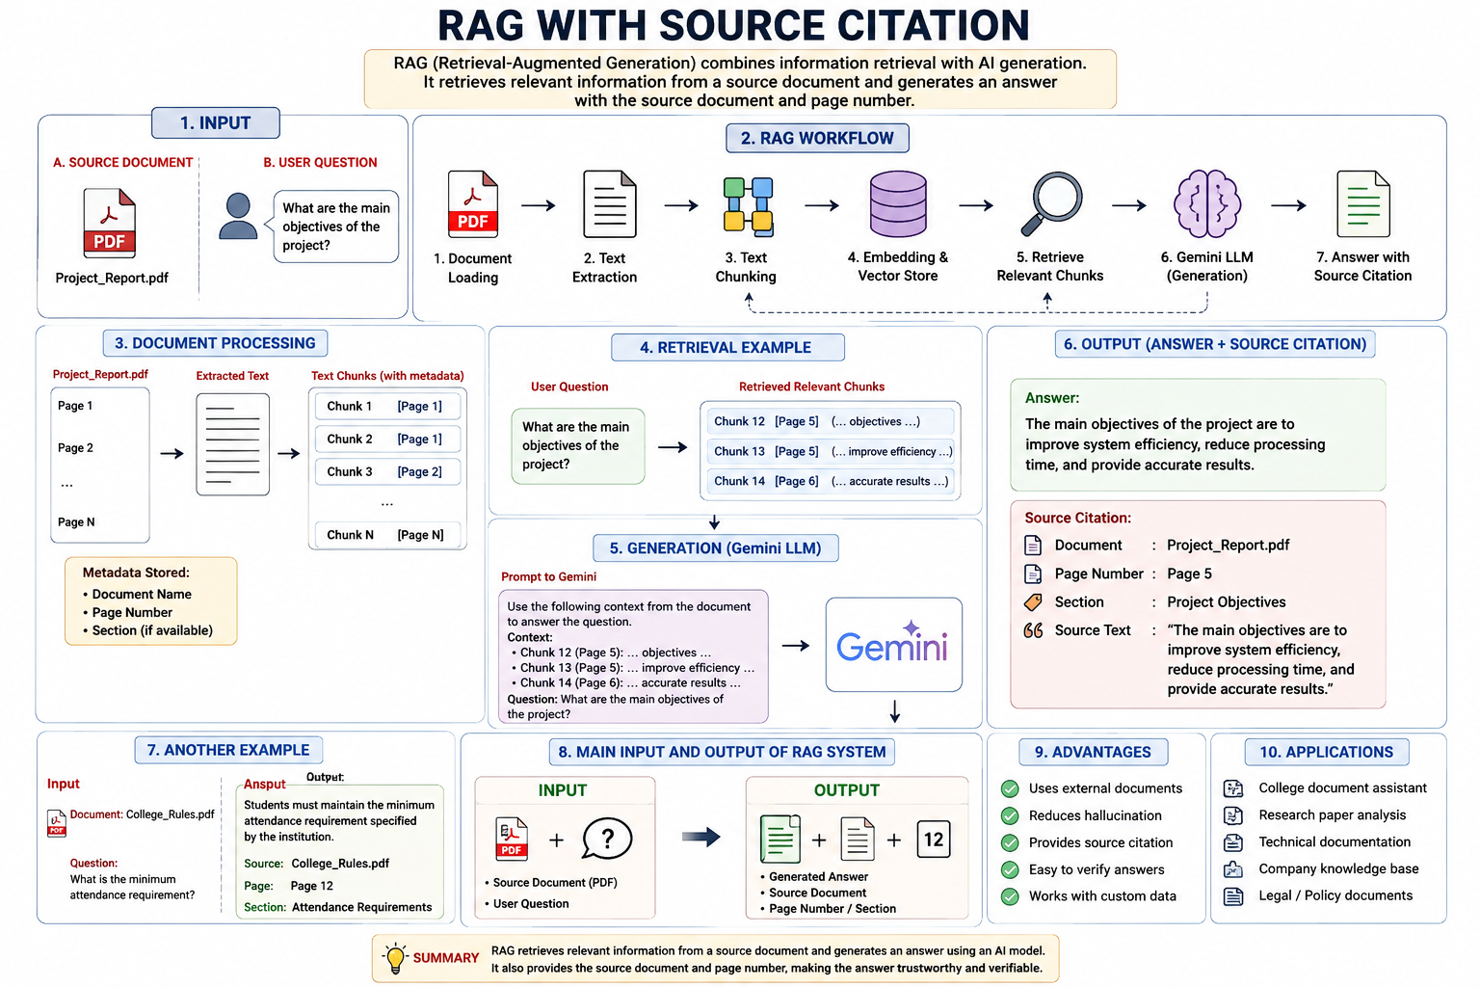

2.TECHNICAL DOCUMENTATION QA USING RAG

1.INTRODUCTION
Technical Documentation Question Answering (QA) is a RAG-based system designed to answer questions using technical documents. The system can process documents such as software manuals, installation guides, configuration guides, API documentation, and troubleshooting manuals. Instead of depending only on the general knowledge of an AI model, the system retrieves relevant information from the technical documentation and uses it to generate an accurate answer.

2. AIM AND OBJECTIVES
The aim of this project is to build a RAG system that can answer questions related to technical documentation. The system should retrieve relevant information and answer configuration, installation, command, and troubleshooting questions. It should also provide the source document and page or section number wherever available.

3. WHAT IS TECHNICAL DOCUMENTATION QA?
Technical Documentation QA is a question-answering system that uses technical documents as its knowledge source. Users can ask questions about how to install software, configure a system, execute commands, or solve common errors. The RAG system searches the documentation and provides an answer based on the retrieved information.

4. RAG WORKING PROCESS
The system first loads the technical documentation and extracts its text. The document is divided into smaller chunks for efficient searching. When the user enters a question, the system retrieves the most relevant sections from the documentation. These sections are provided to the Gemini model as context. Gemini then generates an answer based on the retrieved information and provides the relevant source citation.

Workflow
Technical Documentation
↓
Text Extraction
↓
Chunking
↓
Embedding / Indexing
↓
User Question
↓
Relevant Information
↓
Gemini LLM
↓
Answer + Source

5. TYPES OF QUESTIONS
The RAG system can handle different types of technical questions. Configuration questions ask how to set up a particular option or parameter. Installation questions ask about installing software or dependencies. Command questions ask for the correct command to perform a specific task. Troubleshooting questions describe an error or problem and ask for possible solutions.
For example, a user can ask, "How do I install the software?", "What command starts the server?", "How do I configure the database connection?", or "How can I fix a connection error?"

6. DOCUMENT RETRIEVAL AND ANSWER GENERATION
The technical documentation is processed and stored as searchable chunks. When a user asks a question, the system searches these chunks and retrieves the most relevant information. The retrieved content is then provided to Gemini as context. Gemini uses this information to generate a clear answer. The system can also provide the document name, page number, or section so that the user can verify the answer.

7. INPUT AND OUTPUT
The main input consists of a technical documentation file and a user's technical question.
Input:
Document:
Python_Installation_Guide.pdf

Question:
How do I install Python on Windows?
Output:
Answer:
Download the Python installer from the official source,
run the installer, and complete the installation steps.

Source:
Python_Installation_Guide.pdf

Page:
3

Section:
Installation
Another example can be a troubleshooting question.
Input:
Question:
How can I fix a database connection error?
Output:
Answer:
Check the database server status, verify the connection
settings, and confirm that the configured port is correct.

Source:
Database_Manual.pdf

Page:
18

Section:
Troubleshooting

8. TECHNOLOGIES USED
The system can be implemented using Python, Gemini API, Google GenAI library, PDF processing libraries, embeddings, and a vector search mechanism. Python controls the RAG workflow, while Gemini generates the final response. Technical documentation is used as the external knowledge source.

9. ADVANTAGES AND APPLICATIONS
This system provides quick answers to technical questions and reduces the time required to search through large manuals. It can provide answers based on specific documentation and can include source citations for verification. It can be used for software manuals, API documentation, installation guides, cloud documentation, database manuals, networking guides, and troubleshooting systems.

10. RESULT AND CONCLUSION
The RAG-based Technical Documentation QA system can retrieve relevant information from technical documents and generate answers for configuration, installation, command, and troubleshooting questions. The addition of source information makes the responses easier to verify. The project demonstrates how RAG and Large Language Models can be combined to create a useful technical support assistant.
